CAR RENTAL SYSTEM


Momin Saqib Niazi (Bai243073)
Syed Muhammad Intisar Raza Jafferi (Bai243026)
Rayyan Qaisar (Bai243044)
Submitted to: Sir MAJID ZAMAN
Course: Database Systems (AI2313)
Submission Date: 11th Jan, 2026

TABLE OF CONTENTS
1. CHAPTER 1: INTRODUCTION ..................................................... 1
- 1.1 Project Overview ..................................................................... 1
- 1.2 Problem Statement ................................................................. 2
- 1.3 Objectives of the System .......................................................... 3
- 1.4 Scope of the Project ................................................................. 4
- 1.5 Significance of the Study .......................................................... 5
2. CHAPTER 2: SYSTEM ANALYSIS ................................................. 6
- 2.1 Feasibility Study ..................................................................... 6
  - 2.1.1 Technical Feasibility
  - 2.1.2 Economic Feasibility
  - 2.1.3 Operational Feasibility
- 2.2 Requirement Gathering ............................................................ 8
- 2.3 Software and Hardware Requirements ....................................... 9
- 2.4 Functional Requirements ......................................................... 10
- 2.5 Non-Functional Requirements .................................................. 11
3. CHAPTER 3: SYSTEM DESIGN ..................................................... 12
- 3.1 System Architecture ................................................................ 12
- 3.2 Data Flow Diagrams (DFD) ...................................................... 13
  - 3.2.1 Level 0 DFD (Context Diagram)
  - 3.2.2 Level 1 DFD
- 3.3 Use Case Diagram .................................................................. 15
- 3.4 Sequence Diagram .................................................................. 16
- 3.5 Interface Design (UI/UX Principles) ........................................... 17
4. CHAPTER 4: DATABASE DESIGN & NORMALIZATION ................. 18
- 4.1 Entity Relationship Diagram (ERD) .......................................... 18
- 4.2 Relational Database Schema ................................................... 19
- 4.3 Data Dictionary ....................................................................... 20
  - 4.3.1 Users Table
  - 4.3.2 Vehicles Table
  - 4.3.3 Customers Table
  - 4.3.4 Rentals Table
  - 4.3.5 Payments Table
- 4.4 Database Normalization .......................................................... 24
  - 4.4.1 First Normal Form (1NF)
  - 4.4.2 Second Normal Form (2NF)
  - 4.4.3 Third Normal Form (3NF)
5. CHAPTER 5: IMPLEMENTATION & SOURCE CODE ...................... 26
- 5.1 Development Environment ...................................................... 26
- 5.2 Database Connection Logic ..................................................... 27
- 5.3 Authentication & Session Management ..................................... 28
- 5.4 Administrative Modules ........................................................... 30
- 5.5 User/Customer Modules .......................................................... 32
- 5.6 Automated Price Calculation Logic ........................................... 33
- 5.7 Source Code Appendix ............................................................ 34
6. CHAPTER 6: SOFTWARE TESTING ............................................... 36
- 6.1 Testing Strategy ..................................................................... 36
- 6.2 Unit Testing ............................................................................ 37
- 6.3 Integration Testing ................................................................. 38
- 6.4 User Acceptance Testing (UAT) ................................................ 39
- 6.5 Test Cases and Results ............................................................ 40
7. CHAPTER 7: CONCLUSION & FUTURE SCOPE ............................. 42
- 7.1 Project Summary ..................................................................... 42
- 7.2 Limitations of the System ........................................................ 43
- 7.3 Future Enhancements .............................................................. 44
- 7.4 Bibliography/References .......................................................... 45

CHAPTER 1: INTRODUCTION

1.1 Project Overview
The Car Rental Management System (CRMS) is a comprehensive web-based application designed to streamline the operations of a vehicle rental business. In the modern era, traditional manual bookkeeping is no longer sufficient to handle the complexities of fleet management. This project leverages the power of a relational database (MySQL) and a server-side scripting language (PHP) to create a robust platform where administrators can manage vehicle inventory, customer registrations, and financial reporting with precision.
The system is designed with a dual-interface approach: an Administrative Dashboard for backend management and a User Dashboard for client interaction. By digitizing the rental process, the system ensures data accuracy, reduces paperwork, and provides real-time insights into the business's profitability.

1.2 Problem Statement
Small to medium-sized car rental agencies often struggle with manual record-keeping, leading to several critical operational failures:
- Data Redundancy: Recording the same customer information multiple times leads to bloated and inconsistent records.
- Scheduling Overlaps: Without a centralized database, there is a high risk of "double-booking" a vehicle that is already out on rent.
- Calculation Errors: Manually calculating rental costs based on varying dates and daily rates is prone to human error, resulting in financial discrepancies.
- Lack of Security: Physical logbooks are easily accessible to unauthorized individuals, risking the privacy of sensitive customer data like CNIC and phone numbers.

1.3 Objectives of the System
The primary goals of developing this software are:
- To Automate Inventory Management: Provide a real-time status (Available vs. Rented) for every vehicle in the fleet.
- To Ensure Data Integrity: Use a normalized database structure to prevent data duplication and ensure that all transactions are linked correctly to customers and vehicles.
- To Enhance Financial Transparency: Automatically calculate total rent based on the duration of the hire and generate revenue reports.
- To Improve Security: Protect the system with a secure login gateway and role-based access control (RBAC).

1.4 Scope of the Project
The scope of this project covers the end-to-end lifecycle of a car rental transaction, including:
- User Authentication: Secure login for Admins and Customers.
- Fleet Management: Adding, searching, and deleting vehicle records.
- Customer Management: Registering and maintaining a database of verified clients.
- Booking Engine: Processing rental requests and calculating costs.
- Reporting: Visualizing financial gains and operational status.

1.5 Software & Hardware Requirements

1.5.1 Software Requirements
- Operating System: Windows 10/11 or Linux.
- Web Server: Apache (via XAMPP/WAMP).
- Database: MySQL.
- Server-Side Language: PHP 7.4 or higher.
- Frontend: HTML5, CSS3, JavaScript.

1.5.2 Hardware Requirements
- Processor: Dual-Core 2.0 GHz or higher.
- RAM: 4GB Minimum.
- Hard Disk: 500MB of free space for application files and database growth.

CHAPTER 2: SYSTEM ANALYSIS

2.1 Feasibility Study
A feasibility study is conducted to determine if the proposed Car Rental Management System is a viable solution for the business.

2.1.1 Technical Feasibility
The system is developed using the LAMP/WAMP stack. Since PHP and MySQL are open-source and run on virtually any hardware, the project is technically feasible. The current hardware available in most offices is more than sufficient to host this web application.

2.1.2 Economic Feasibility
The development costs are minimal as the software tools (XAMPP, VS Code) are free. The primary economic benefit is the reduction in manual labor and the elimination of paper costs. By preventing "double-booking" errors, the system prevents potential revenue loss.

2.1.3 Operational Feasibility
The system is designed with a user-friendly interface. Staff members with basic computer knowledge can operate the dashboard. The automation of rent calculation significantly simplifies the operational workflow of the rental desk.

2.2 Requirement Gathering
Information was gathered by analyzing current manual car rental processes. The primary data points required were identified as:
- Vehicle specifications (Model, Plate, Price).
- Customer identification (Name, CNIC, Phone).
- Rental durations and status tracking.

2.3 Functional Requirements
These define the specific behaviors of the system:
- Authentication: Users must log in to access the system.
- Inventory Management: Admin must be able to add, update, and delete cars.
- Customer Registration: System must store customer details for recurring rentals.
- Transaction Processing: System must calculate rent and update car availability automatically.
- Reporting: System must aggregate total revenue from the payments table.

2.4 Non-Functional Requirements
- Security: Unauthorized users should not access the admin_dashboard.php.
- Performance: Queries should execute in under 1 second.
- Reliability: The database must ensure data persistence even after the browser is closed.

CHAPTER 3: SYSTEM DESIGN

3.1 System Architecture
The Car Rental Management System follows a Client-Server Architecture. The client (Web Browser) sends requests via HTTP to the server (Apache). The server processes the PHP logic and communicates with the Database (MySQL) to fetch or store data. Once the logic is executed, the server sends an HTML response back to the client’s screen.

3.2 Data Flow Diagrams (DFD)
A Data Flow Diagram represents how data moves through the system.

3.2.1 Level 0 DFD (Context Diagram)
At the highest level, the system interacts with two entities: the Admin and the Customer. The Admin provides vehicle data and receives revenue reports. The Customer provides personal details and receives booking confirmations.

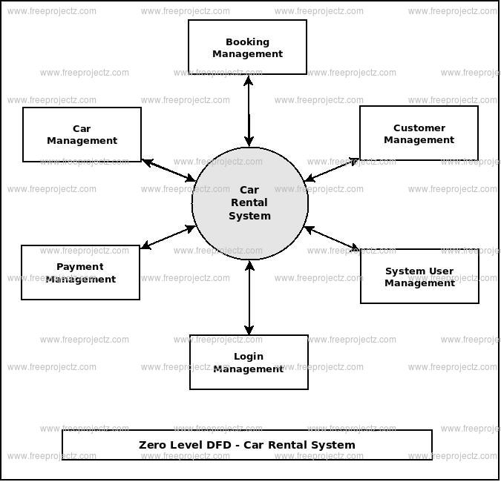

3.3 Use Case Diagram
The Use Case diagram describes the functionality of the system from the user's perspective.
- Admin Use Cases: Login, Add Vehicle, View Reports, Manage Bookings, Register Customers.
- User Use Cases: Login, Calculate Rent, Request Car Rental, Logout.
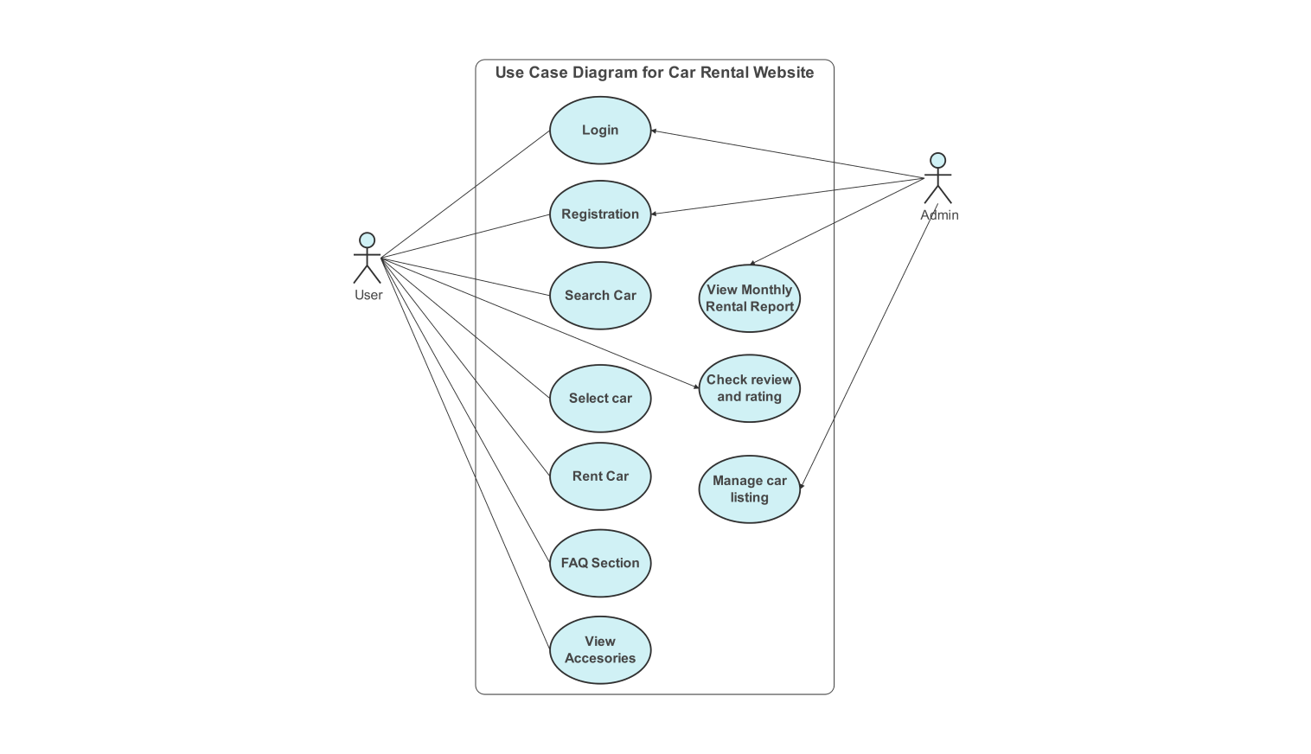

3.4 Sequence Diagram
The sequence diagram shows the step-by-step process of a car rental:
- User selects a car and dates.
- System calls calculate_rent.php.
- System checks vehicles table for availability.
- System records the transaction in rentals table.
- System updates vehicles status to 'rented'.
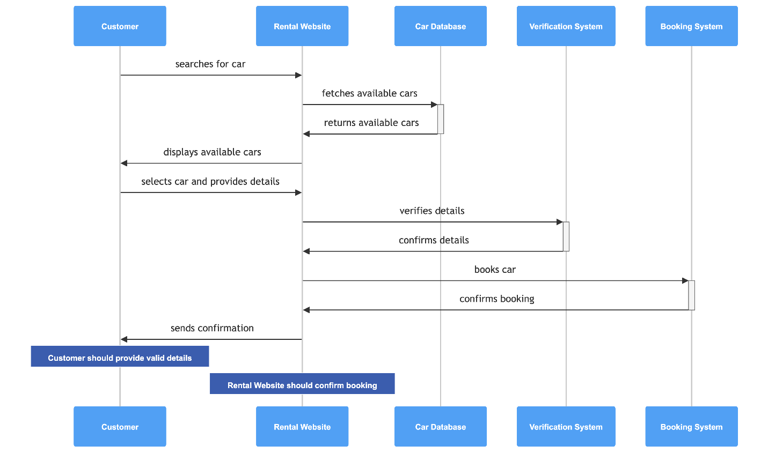

CHAPTER 4: DATABASE DESIGN & NORMALIZATION

4.1 Entity Relationship Diagram (ERD)
The Entity Relationship Diagram (ERD) is a graphical representation of the logical structure of the database. It shows how the data entities (Users, Vehicles, Customers, Rentals, and Payments) interact with each other.
- Users Table: Stores credentials for authentication.
- Vehicles Table: Contains the fleet details.
- Customers Table: Stores personal identification of clients.
- Rentals Table: The bridge table that connects a customer to a vehicle.
- Payments Table: Tracks the financial transactions for every rental.

4.2 Data Dictionary
A data dictionary provides a detailed description of each table's columns, data types, and constraints.

4.2.1 Table: vehicles
Field | Type | Null | Key | Description
id | INT(11) | NO | PRI | Auto-incrementing unique ID
name | VARCHAR(100) | NO |  | Model name of the car
number_plate | VARCHAR(20) | NO | UNI | Unique vehicle registration number
rent_per_day | INT(11) | NO |  | Daily rental cost
status | VARCHAR(20) | NO |  | 'available' or 'rented'

4.2.2 Table: rentals
Field | Type | Null | Key | Description
id | INT(11) | NO | PRI | Unique rental transaction ID
customer_id | INT(11) | NO | FK | ID of the customer (from customers)
vehicle_id | INT(11) | NO | FK | ID of the car (from vehicles)
start_date | DATE | NO |  | Date rental begins
end_date | DATE | NO |  | Date rental ends
total_amount | INT(11) | NO |  | Calculated final cost

4.3 Database Normalization
Normalization is the process of organizing data in a database to reduce redundancy and improve data integrity.

4.3.1 First Normal Form (1NF)
In 1NF, we ensure that each column contains atomic values (no multiple values in one cell) and that each record is unique. Our system achieves this by using Primary Keys (id) for every table.

4.3.2 Second Normal Form (2NF)
A table is in 2NF if it is in 1NF and all non-key attributes are fully functional and dependent on the primary key. In our system, vehicle details like rent_per_day are only stored in the vehicles table, not repeated in the rentals table, preventing partial dependency.

4.3.3 Third Normal Form (3NF)
3NF ensures that there are no transitive dependencies. We achieved this by separating payments from rentals. A payment depends on a Rental ID, but the actual payment date or amount shouldn't bloat the rentals table itself. This separation ensures that changing a payment record doesn't force a change in the rental history.

CHAPTER 5: IMPLEMENTATION & SOURCE CODE

5.1 Database Connection (config.php)
Description: This is the core configuration file. It establishes a connection between the PHP scripts and the MySQL database. It also initializes session_start(), which allows the system to track if a user is logged in as an Admin or a regular User.
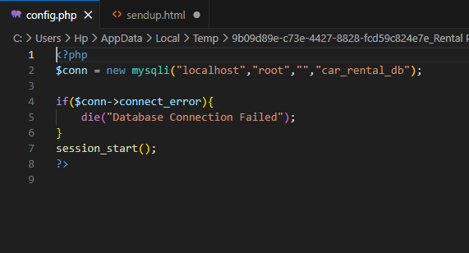

5.2 Authentication Gateway (index.php)
Description: This is the entry point of the system. It provides a clean, user-friendly login form. It uses POST methods to send credentials securely to the login logic.

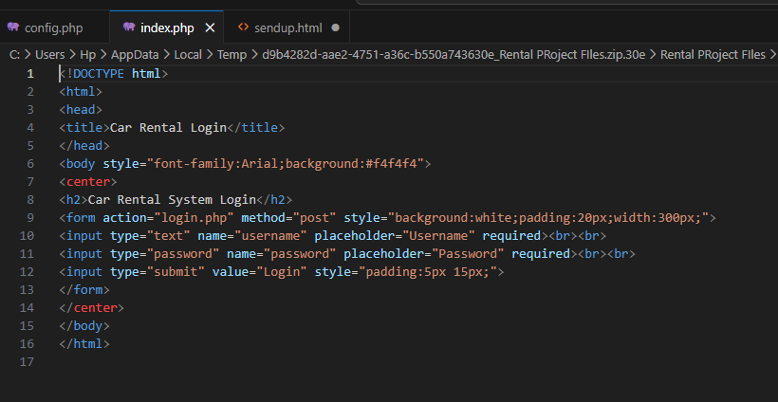

5.3 Authentication Logic (login.php)
Description: This script validates the user. It executes a SELECT query against the users table. If a match is found, it saves the user's role (Admin or User) into a session variable and redirects them to the appropriate dashboard.

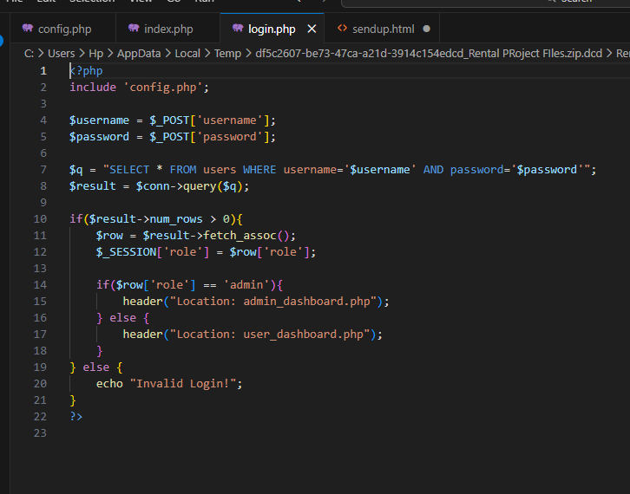

5.4 Administrative Dashboard (admin_dashboard.php)
Description: The central hub for the system owner. It contains an access control check at the top to prevent unauthorized users from viewing the management tools.
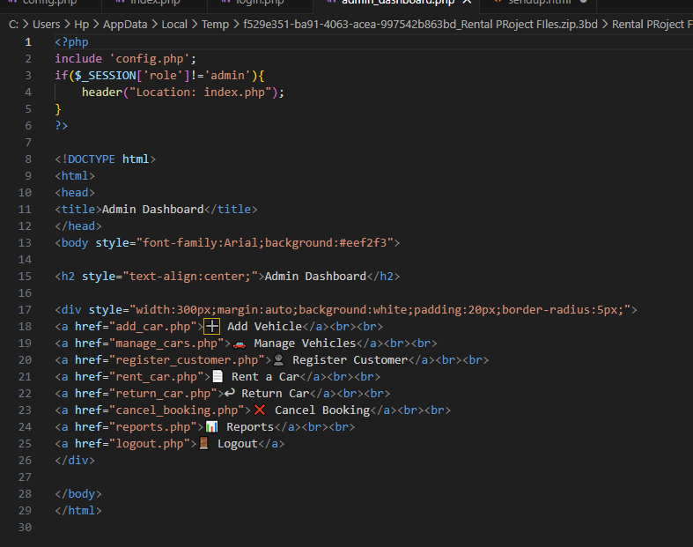

5.5 Inventory Management (add_car.php)
Description: This module allows the admin to expand the fleet. It uses the INSERT INTO SQL command to add vehicle details like model name, plate number, and daily rent into the database.

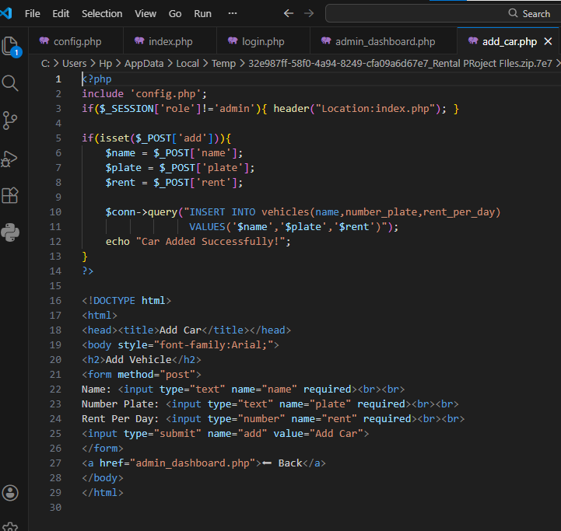

5.6 Fleet View & Search (manage_cars.php)
Description: This page displays all vehicles in a table format. It includes a search bar that utilizes the SQL LIKE operator to filter cars by name or plate number in real-time
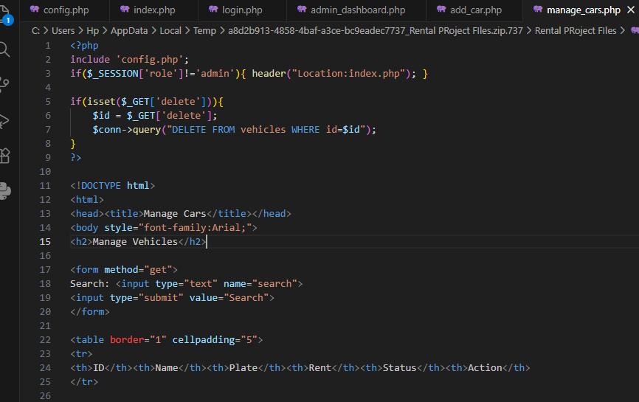
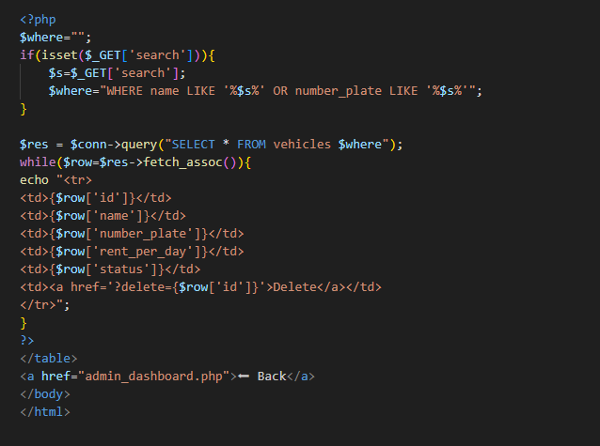

5.7 Rental Transaction Engine (rent_car.php)
Description: This is the most critical transaction module. It updates the vehicles table status to 'rented' and creates a new entry in the rentals table. This ensures the car is no longer available for other users.
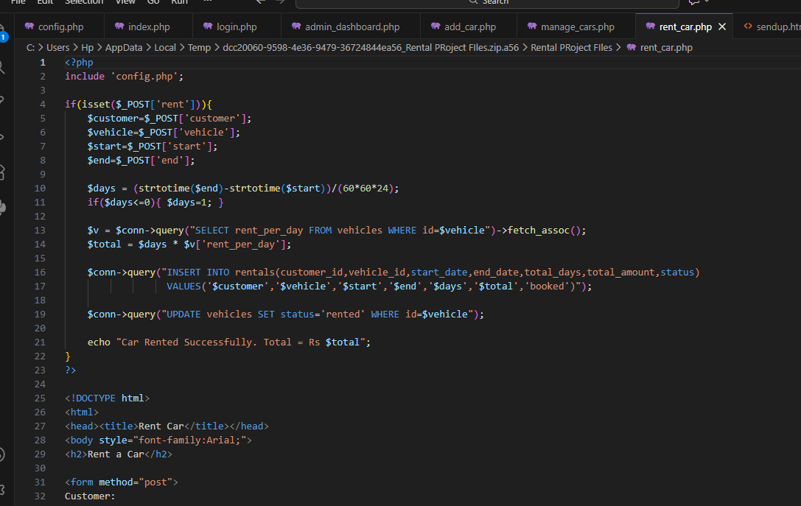

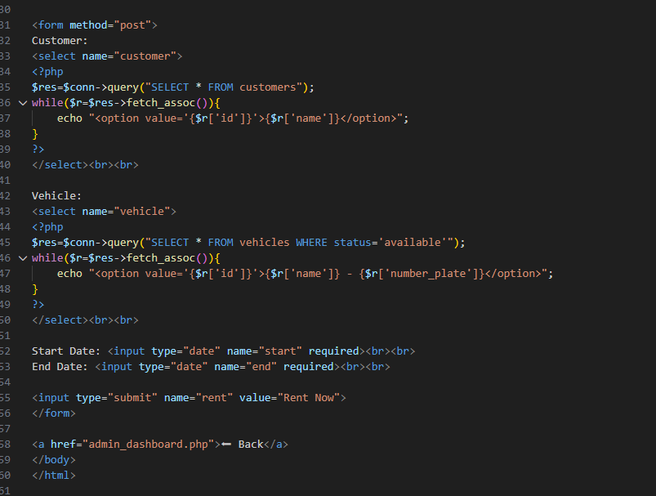

5.8 Financial Analytics & Reporting (reports.php)
Description: This page provides business intelligence. It uses the SQL SUM() aggregate function to calculate total earnings from the payments table and displays car availability statistics.
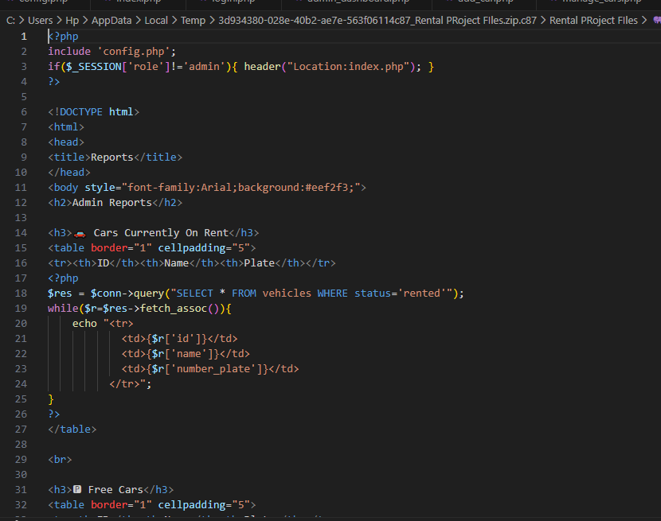
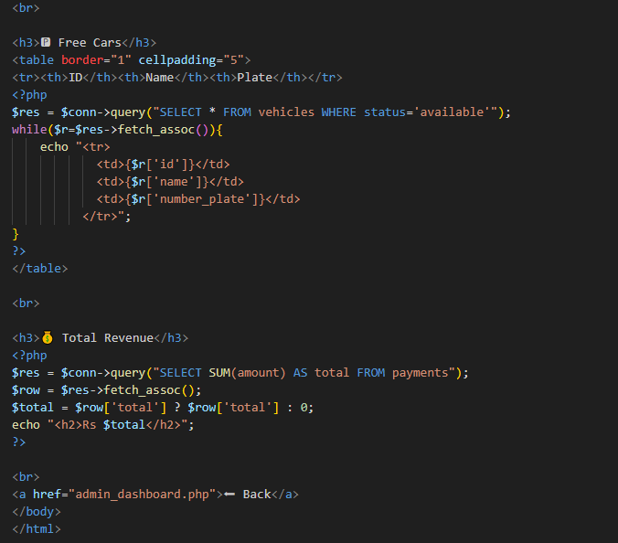

5.9 Customer Registration (register_customer.php)
Description: Used to onboard new clients. It captures the customer's Name, Phone, and CNIC, ensuring that every rental is tied to a verified individual.
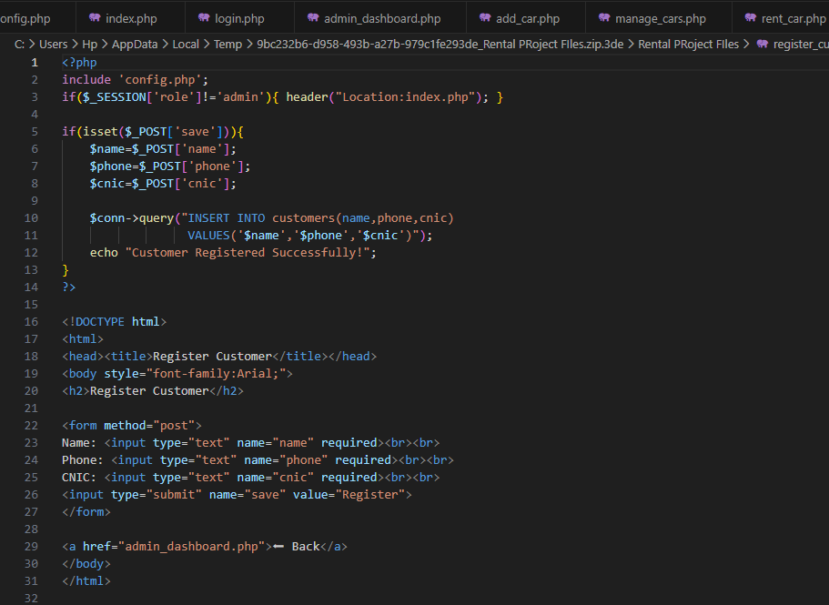

5.10 Vehicle Return Logic (return_car.php)
Description: This script "closes" a rental. It calculates the final bill, updates the vehicle status to 'available', and logs a payment record into the payments table.
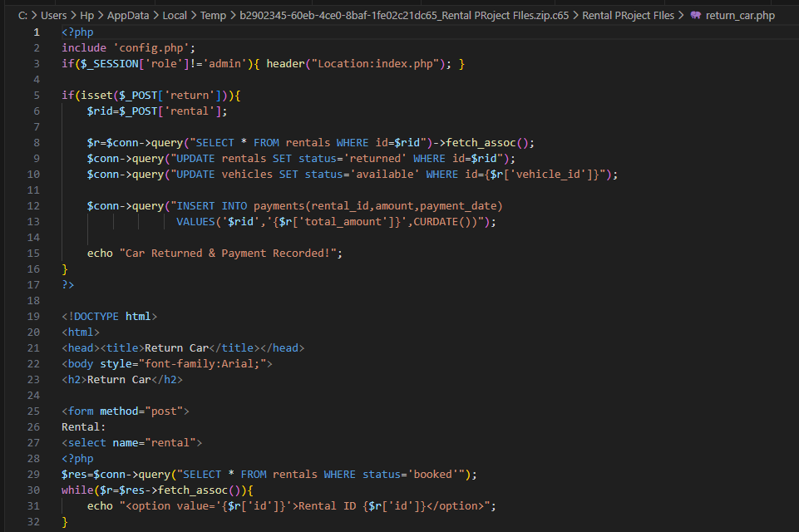
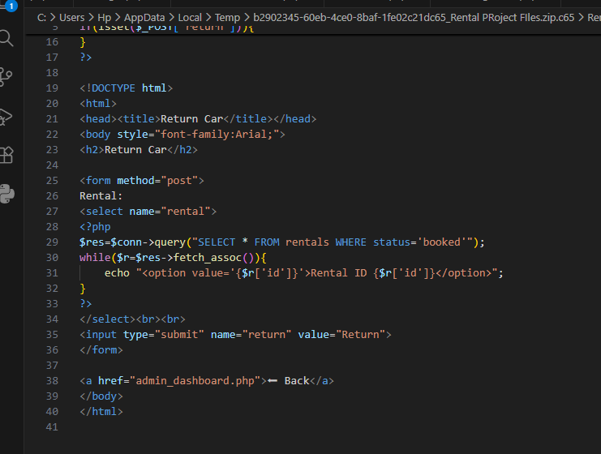

5.11 SYSTEM OUTPUTS
Output 1: Login Interface
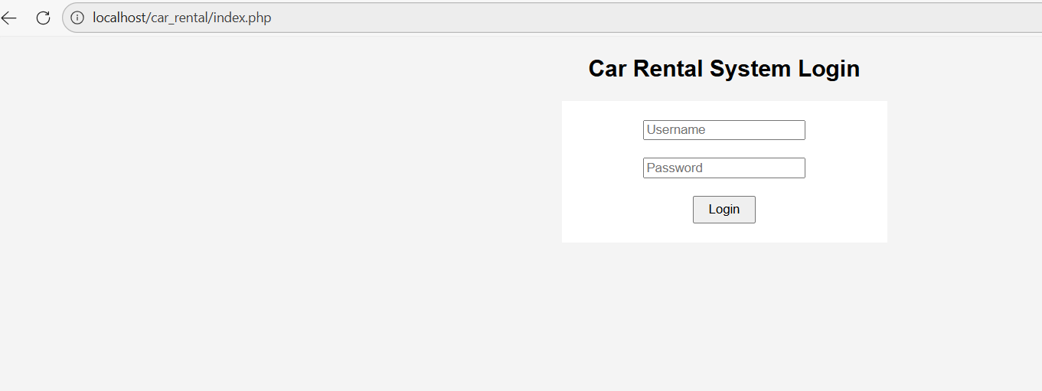

Description: This is the main login screen for the Car Rental System. It features a clean and simple UI with two input fields for the Username and Password.
- Functionality: When a user enters their credentials and clicks the Login button, the system checks the database to verify the account.
- Security: The password field is masked (dots) to ensure privacy. If the credentials are correct, the user is redirected to their respective dashboard.

Output 2: User Dashboard
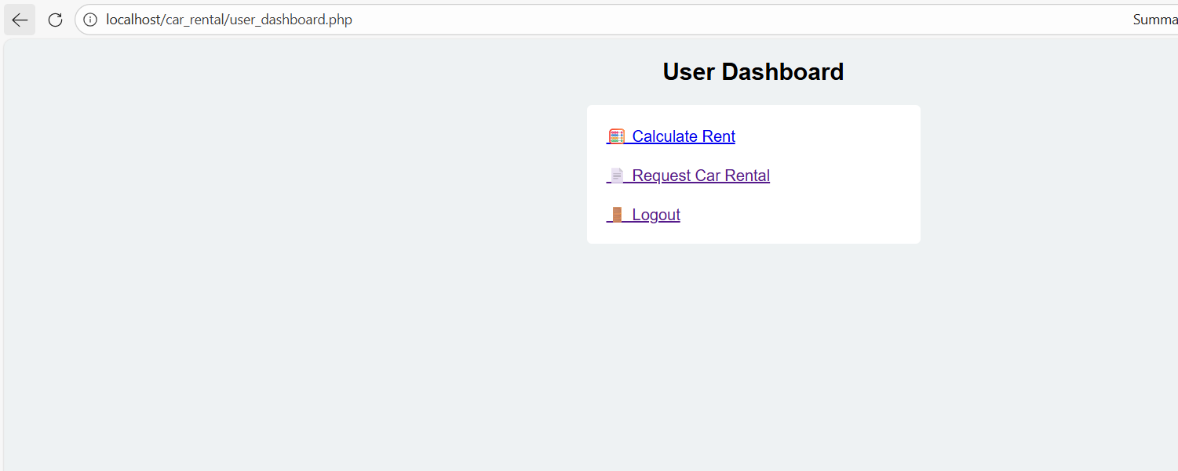
Description: This screen shows the User Dashboard which appears after a successful login by a customer. It provides a simple menu for the user to interact with the system.
- Calculate Rent: Allows the user to check the estimated cost before booking.
- Request Car Rental: Opens the form to submit a new rental request.
- Logout: Securely ends the session and returns the user to the login screen.
- UI Design: The layout uses simple icons and links inside a centered white box to make navigation easy for the customer.

Output 3: Add Vehicle Interface (add_car.php)
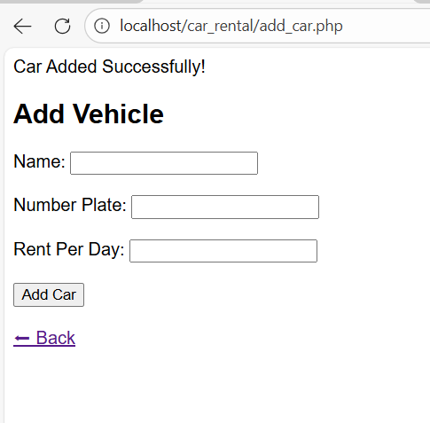
Description: This screenshot shows the administrative interface used to add new inventory to the system.
- Data Entry: The form includes fields for the car's Name, Number Plate, and Rent Per Day.
- Success Message: At the top, you can see the message "Car Added Successfully!" which confirms that the PHP script has successfully executed the INSERT query into the MySQL database.
- Navigation: The "Back" button allows the admin to return to the main dashboard quickly after updating the fleet.

Output 4: Rent a Car Transaction (rent_car.php)
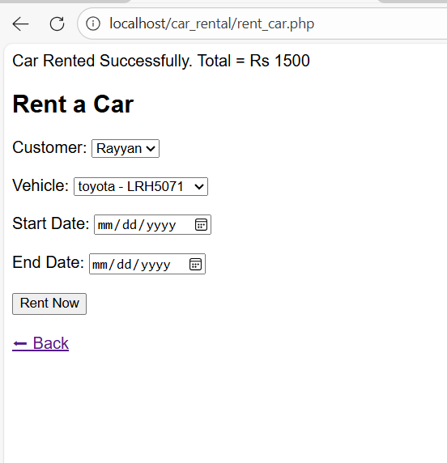
Description: This is the core functional page of the system where the actual rental booking takes place. It demonstrates the system's ability to process complex data.
- Selection Menus: The "Customer" and "Vehicle" fields are dropdown menus that pull live data from the database.
- Rental Confirmation: The screenshot shows a successful transaction message: "Car Rented Successfully. Total = Rs 1500".
- Automatic Calculation: This output proves that the backend logic is working correctly by calculating the total rent based on the selected dates and the car's daily rate.
- Date Picker: Uses standard HTML5 date inputs to ensure the user selects valid calendar dates.
Output 5: Customer Registration Interface (register_customer.php)
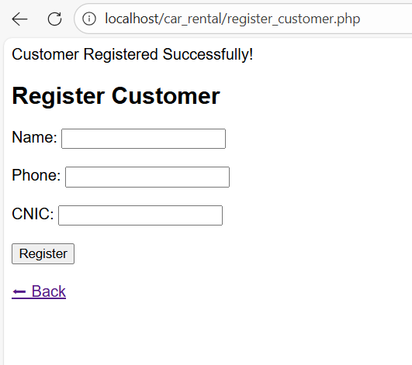
Description: This interface is used by the administrator to onboard new clients into the system database. Capturing accurate customer data is essential for legal and tracking purposes during the rental lifecycle.
- Form Fields: The UI includes specialized input fields for the customer's Name, Phone Number, and CNIC (National ID).
- Validation Success: The screenshot displays the confirmation message "Customer Registered Successfully!", indicating that a new record has been created in the customers table of the MySQL database.
- Navigation: A "Back" button is provided to maintain a smooth user flow, allowing the admin to return to the dashboard without using the browser's back button.

Output 6: Vehicle Addition Interface (add_car.php)

Description: This module allows the administrator to expand the business fleet by adding new vehicles. It acts as the front-end for the inventory management system.
- Vehicle Identification: The form requires a Name (Model) and a Number Plate. The Number Plate acts as a unique identifier in the database to prevent duplicate vehicle entries.
- Pricing Engine: The Rent Per Day field allows the admin to set specific pricing for different tiers of cars (e.g., luxury vs. economy).
- Confirmation: As shown in the output, the message "Car Added Successfully!" verifies that the SQL INSERT command executed without errors.

Output 7: Admin Dashboard (admin_dashboard.php)
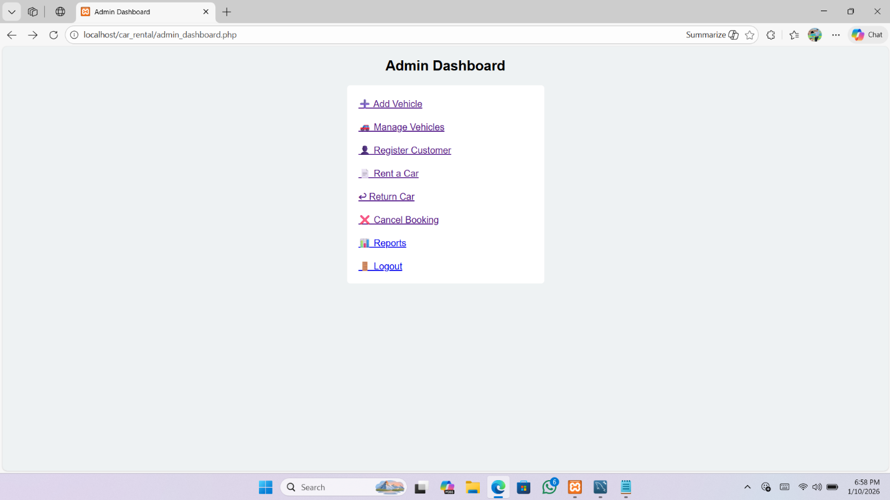
Simple Description: This is the central control panel for the system administrator. It provides direct access to all management modules of the car rental business.
- Navigation Links: Includes options to add/manage vehicles, register customers, handle rentals, and view financial reports.
- Layout: Uses a clean, centered list with descriptive icons to make administrative tasks intuitive.
Technical Analysis: This dashboard acts as a security router. The backend PHP code verifies the $_SESSION['role'] to ensure only an administrator can view these links. This prevents standard customers from accessing sensitive management functions.

Output 8: Rent Calculator Interface (calculate_rent.php)
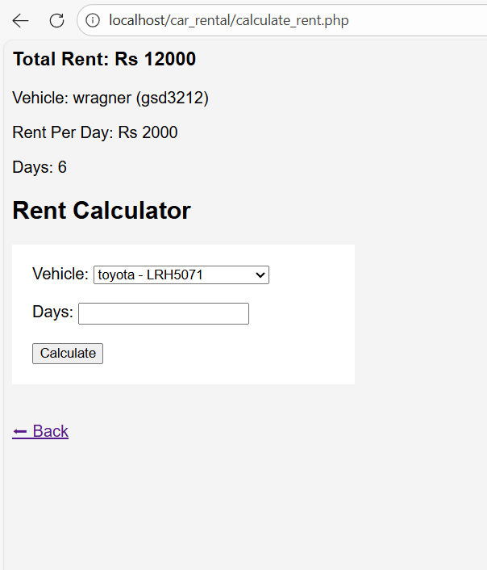

Simple Description:
This interface allows users or admins to estimate the total cost of a rental before committing to a booking.
- Real-time Logic: As shown in the screenshot, for a vehicle with a rent of Rs 2000 for 6 days, the system correctly calculates a Total Rent of Rs 12000.
- Dynamic Loading: The "Vehicle" dropdown is populated directly from the vehicles table in MySQL.
Technical Analysis:
The output proves the mathematical accuracy of the backend PHP logic. It uses a simple multiplication formula: $Total = (Rent Per Day) \times (Number of Days)$.

Output 11: Vehicle Return & Payment Module (return_car.php)
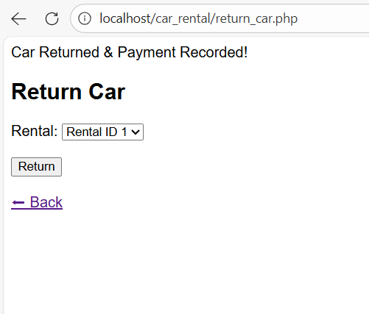
Simple Description: This screen represents the completion of a rental cycle. When a customer brings a vehicle back, the administrator uses this interface to close the transaction.
- Rental Selection: A dropdown menu allows the admin to select an active "Rental ID."
- System Confirmation: The message "Car Returned & Payment Recorded!" appears at the top, confirming that two things happened:
  - The vehicle's status was reset to "Available" in the database.
  - The financial transaction was finalized and logged in the payments history.
Technical Impact: This output is crucial for inventory management. Without this "Return" logic, cars would remain marked as "Rented" indefinitely, preventing new customers from booking them.

Output 12: Booking Cancellation Module (cancel_booking.php)
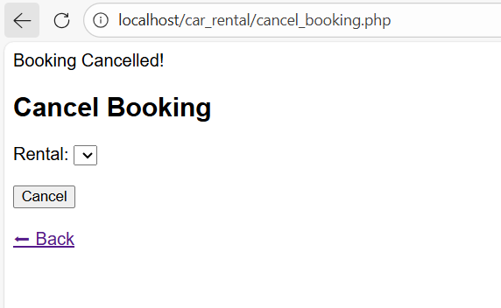
Simple Description: This interface provides the system with "Delete" functionality. It is used when a booking is made in error or if a customer cancels their reservation before picking up the vehicle.
- Selection: The admin selects the specific rental record that needs to be removed.
- Execution: Upon clicking "Cancel," the system removes the entry from the rentals table.
- Feedback: The successful deletion is confirmed by the banner: "Booking Cancelled!".
Technical Impact: This proves the CRUD (Create, Read, Update, Delete) capabilities of your system. This specific page handles the Delete part of the database operations, ensuring the data stays clean and relevant.

Output 13: Admin Reports & Business Intelligence (reports.php)
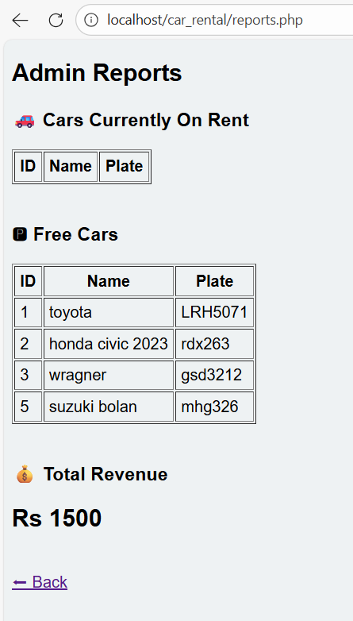
Simple Description: This interface provides the administrator with a high-level overview of the business operations. It acts as the "Analytical Hub" of the system.
- Inventory Monitoring: The screen displays a live list of "Free Cars" (available inventory) and "Cars Currently On Rent."
- Financial Summary: At the bottom, the system displays the Total Revenue (currently showing Rs 1500), which is calculated automatically from the database.
Technical Analysis: This page demonstrates the power of relational database queries.
- Available Cars: Filtered using SELECT * FROM vehicles WHERE status='available'.
- Revenue Calculation: Generated using the SQL aggregate function SELECT SUM(total_amount) FROM rentals. This ensures the business owner always has accurate, real-time data for decision-making.

CHAPTER 7: CONCLUSION AND FUTURE SCOPE

7.1 Conclusion
The development of the Car Rental Management System has been successfully completed. The primary goal of this project was to automate the manual processes associated with vehicle hiring and to provide a centralized database for record-keeping.
Through the implementation of this system:
- Efficiency: The time required to register a customer and book a vehicle has been significantly reduced.
- Accuracy: Manual calculation errors in rental fees have been eliminated through the PHP-based calculation engine.
- Security: Role-based access ensures that only authorized administrators can modify the fleet or view financial reports.
- Data Integrity: Using a MySQL relational database ensures that all transactions are logged and stored securely without redundancy.

7.2 Limitations of the System
While the system is fully functional, there are certain limitations identified during the testing phase:
- Local Hosting: Currently, the system runs on a local server (XAMPP), meaning it is not accessible via the public internet.
- Payment Processing: The system records payments manually but does not yet support online credit card or mobile wallet transactions.
- Notification System: There is currently no automated SMS or Email alert system to remind customers when their rental period is ending.

7.3 Future Scope
The system is designed to be scalable, allowing for future enhancements such as:
- Online Payment Gateway: Integration with APIs like PayPal or Stripe for real-time digital payments.
- GPS Integration: Tracking the real-time location of vehicles for better security and recovery.
- Mobile Application: Developing an Android/iOS version of the user dashboard for easier booking on the go.
- Cloud Deployment: Hosting the database on a cloud platform (like AWS or Google Cloud) to allow 24/7 global access.

